Medical OCR API — Assignment Summary Report
Project: Medical OCR API (Home Assessment – OCR Endpoint Challenge)
Author: Shou Yichen
Date: 2026-08-05 Tech Stack: FastAPI + Tesseract (pytesseract) + OpenAI LLM + OpenCV Test Environment: macOS 26.6 (arm64) on Apple M1 Pro (8 cores); Python 3.9.6 (project .venv); pytest 8.4.2; Tesseract 5.5.3 (/opt/homebrew/bin/tesseract); automated tests: 5 passed, 5 warnings
──────────────────────────────────────────────────

Table of Contents
- Pipeline Architecture
- API Input & Output Results
- Error Handling Verification
- Performance Summary
- Key Design Decisions
──────────────────────────────────────────────────

1. Pipeline Architecture

1.1 Architecture Diagram

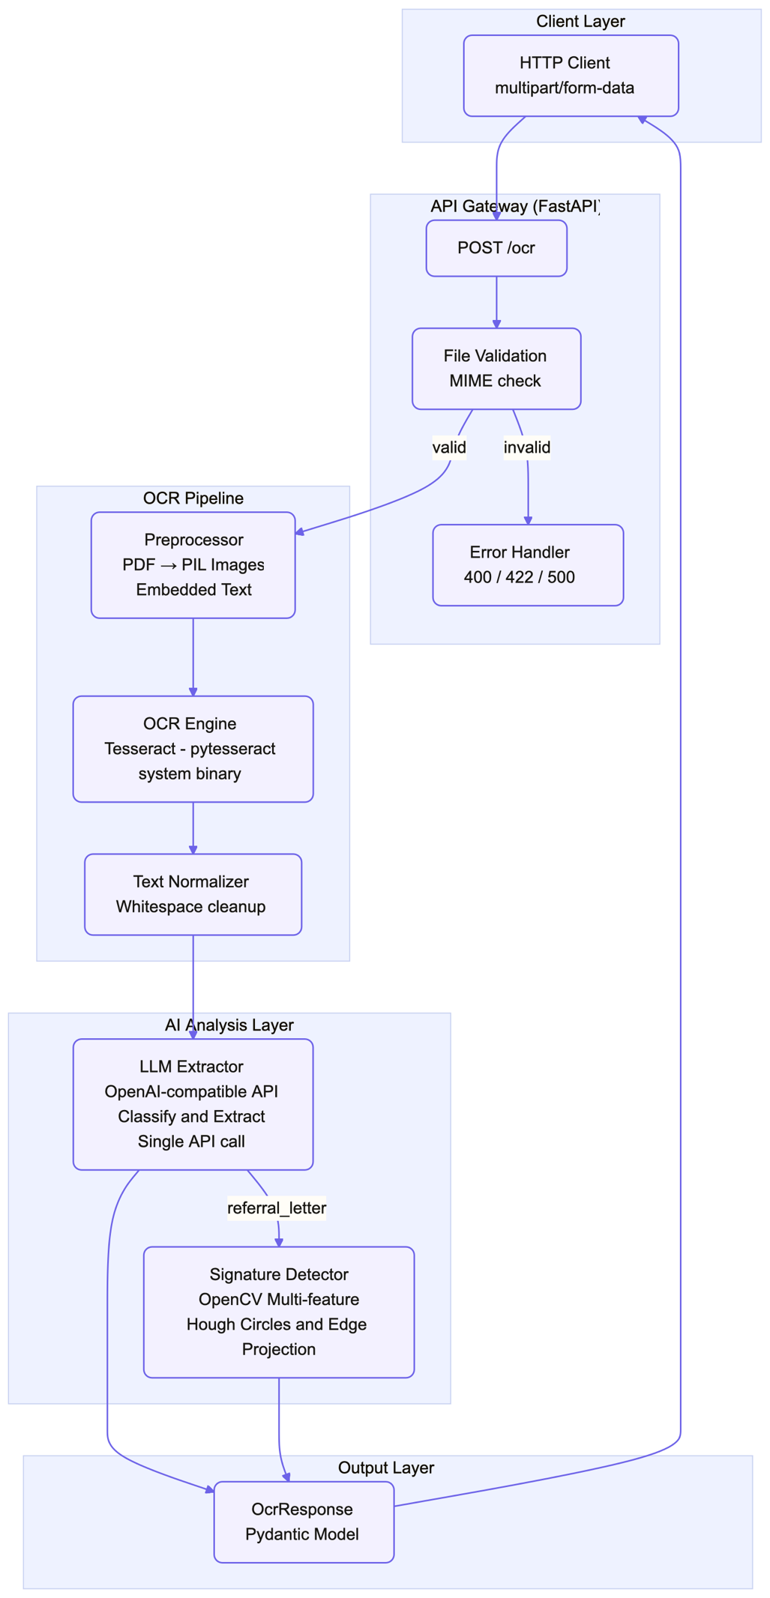

1.2 Web UI
The project includes a browser-based drag-and-drop interface for easy testing:
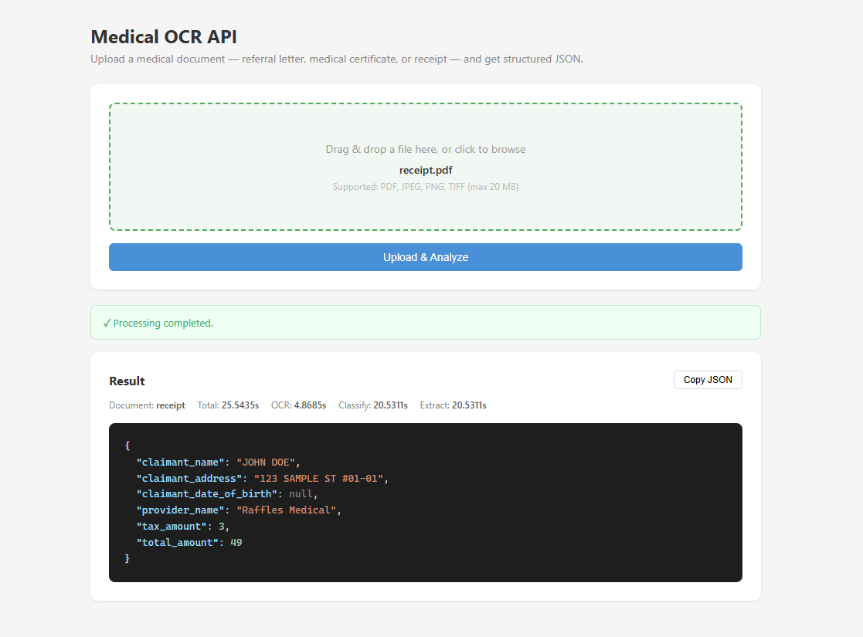

1.3 Online Demo
The deployed online demo is available at:
- https://medical-ocr.greensky-c0f2aeba.eastasia.azurecontainerapps.io

1.4 Online Test Cases
The following curl requests use the repository sample files with relative paths:
# Referral Letter
curl --fail-with-body -X POST "https://medical-ocr.greensky-c0f2aeba.eastasia.azurecontainerapps.io/ocr" \
-F "file=@Example/referral_letter.pdf"

# Medical Certificate
curl --fail-with-body -X POST "https://medical-ocr.greensky-c0f2aeba.eastasia.azurecontainerapps.io/ocr" \
-F "file=@Example/medical_certificate.pdf"

# Receipt
curl --fail-with-body -X POST "https://medical-ocr.greensky-c0f2aeba.eastasia.azurecontainerapps.io/ocr" \
-F "file=@Example/receipt.pdf"
──────────────────────────────────────────────────

2. API Input & Output Results

2.1 Referral Letter
Input: Example/referral_letter.pdf
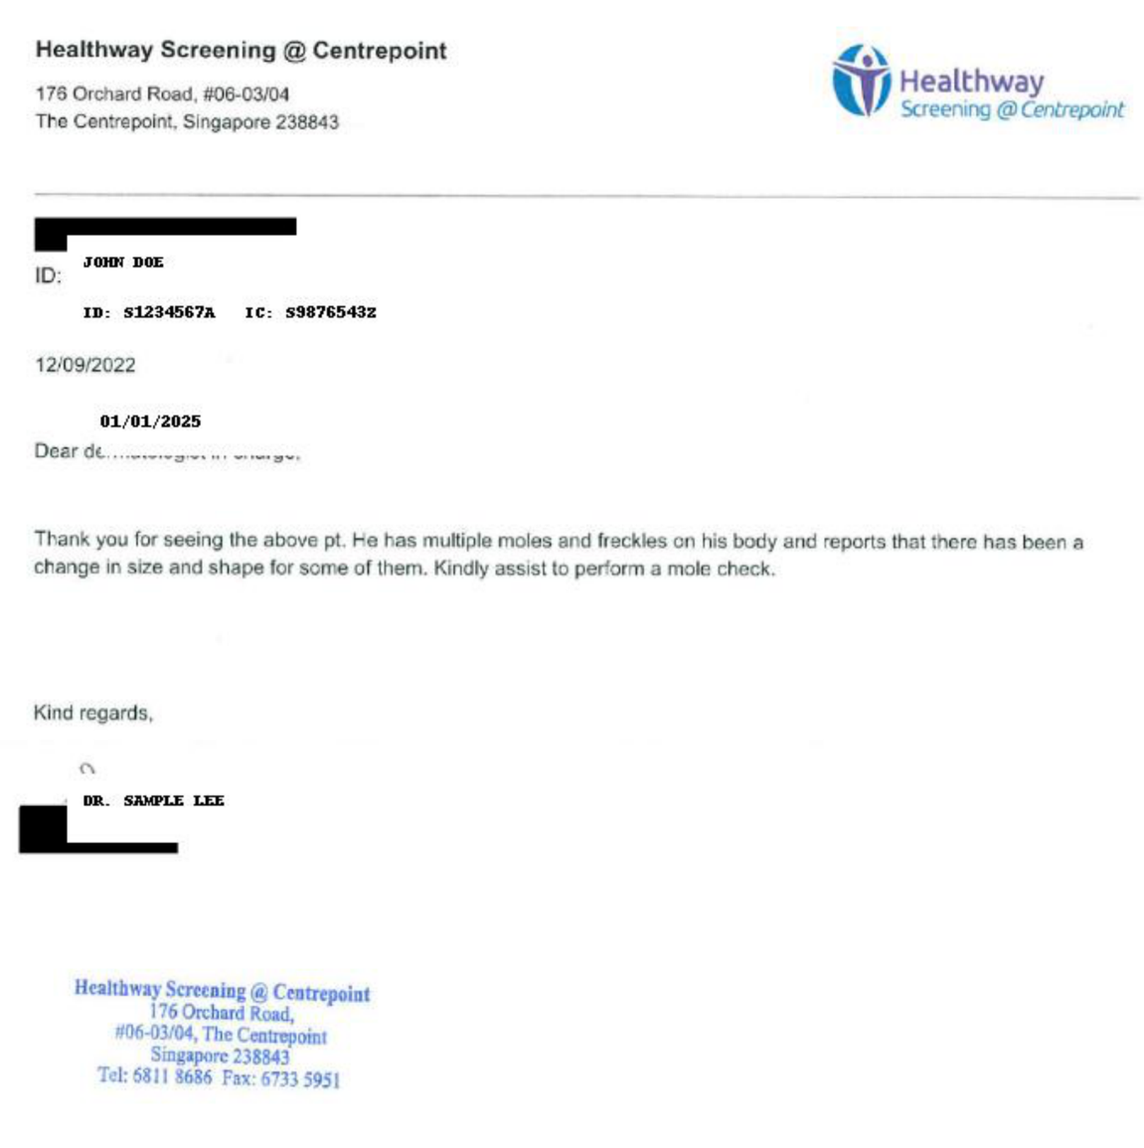
Request:
POST /ocr
Content-Type: multipart/form-data
file=@Example/referral_letter.pdf
Output (200 OK):
{
"message": "Processing completed.",
"result": {
"document_type": "referral_letter",
"total_time": 22.7419,
"ocr_time": 6.8492,
"classification_time": 15.6972,
"extraction_time": 15.6972,
"finalJson": {
"claimant_name": "JOHN DOE",
"provider_name": "Healthway Screening @ Centrepoint",
"signature_presence": false,
"total_amount_paid": null,
"total_approved_amount": null,
"total_requested_amount": null
}
}
}
Field verification:
Field | Expected | Actual | ✓/✗
claimant_name | Patient Name | "JOHN DOE" | ✓
provider_name | No “Fullerton Health” | "Healthway Screening @ Centrepoint" | ✓
signature_presence | true/false | false | ✓
total_amount_paid | Integer | null (not present in doc) | ✓
total_approved_amount | Integer | null (not present in doc) | ✓
total_requested_amount | Integer | null (not present in doc) | ✓
Note on @ symbol: The LLM prompt includes OCR correction for @ misread as 0, o, a, or at. The provider name "Healthway Screening @ Centrepoint" was correctly extracted.
──────────────────────────────────────────────────

2.2 Medical Certificate
Input: Example/medical_certificate.pdf
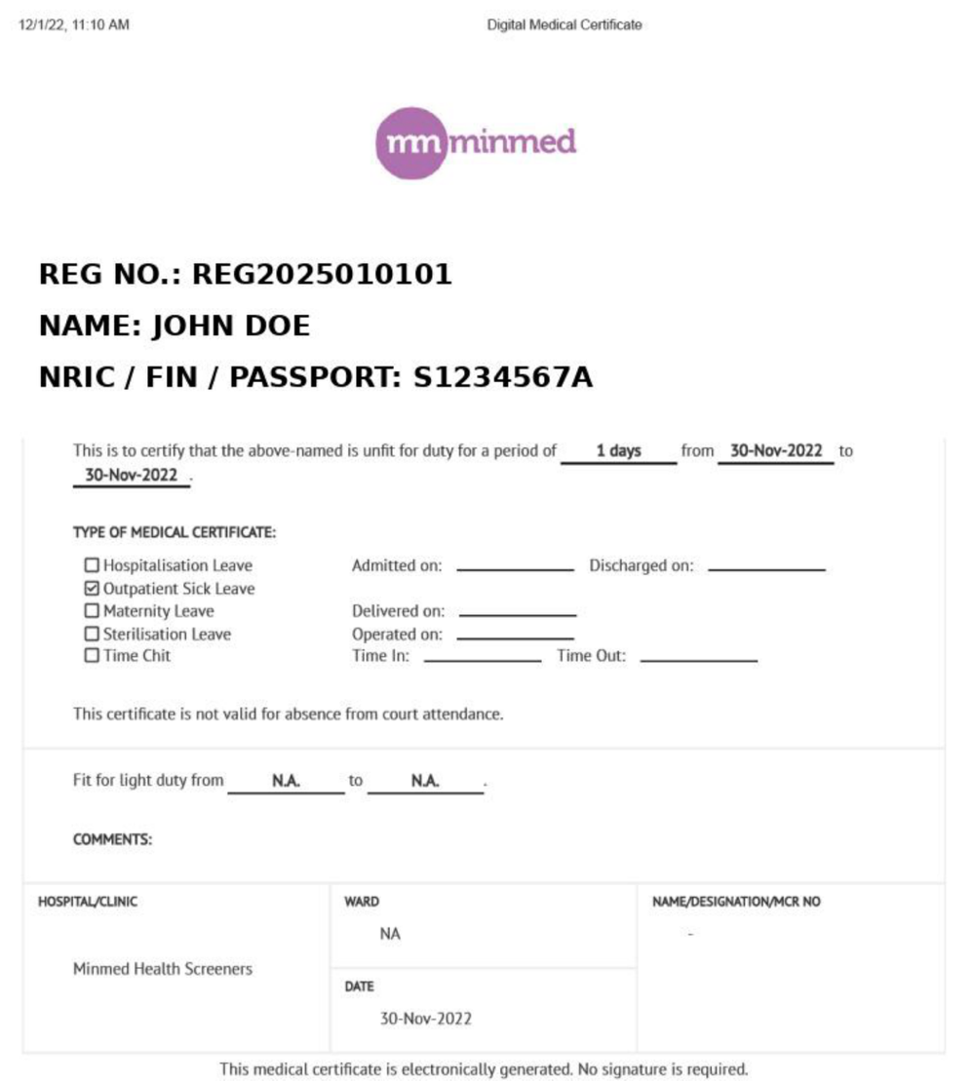
Request:
POST /ocr
Content-Type: multipart/form-data
file=@Example/medical_certificate.pdf
Output (200 OK):
{
"message": "Processing completed.",
"result": {
"document_type": "medical_certificate",
"total_time": 21.4516,
"ocr_time": 2.7371,
"classification_time": 18.5032,
"extraction_time": 18.5032,
"finalJson": {
"claimant_name": "JOHN DOE",
"claimant_address": null,
"claimant_date_of_birth": null,
"diagnosis_name": null,
"discharge_date_time": null,
"icd_code": null,
"provider_name": "Minmed Health Screeners",
"submission_date_time": null,
"date_of_mc": "30/11/2022",
"mc_days": 1
}
}
}
Field verification:
Field | Expected | Actual | ✓/✗
claimant_name | Claimant Name | "JOHN DOE" | ✓
claimant_address | Address | null (not in doc) | ✓
claimant_date_of_birth | DD/MM/YYYY | null (not in doc) | ✓
diagnosis_name | Diagnosis | null (not in doc) | ✓
discharge_date_time | DD/MM/YYYY | null (not in doc) | ✓
icd_code | ICD code | null (not in doc) | ✓
provider_name | No “Fullerton Health” | "Minmed Health Screeners" | ✓
submission_date_time | DD/MM/YYYY | null (not in doc) | ✓
date_of_mc | DD/MM/YYYY | "30/11/2022" | ✓
mc_days | Integer | 1 | ✓
──────────────────────────────────────────────────

2.3 Receipt
Input: Example/receipt.pdf
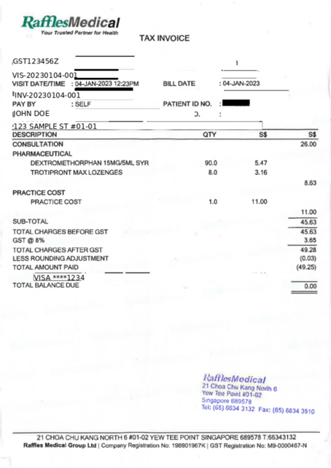
Request:
POST /ocr
Content-Type: multipart/form-data
file=@Example/receipt.pdf
Output (200 OK):
{
"message": "Processing completed.",
"result": {
"document_type": "receipt",
"total_time": 26.1796,
"ocr_time": 5.476,
"classification_time": 20.5064,
"extraction_time": 20.5064,
"finalJson": {
"claimant_name": "JOHN DOE",
"claimant_address": "123 SAMPLE ST #01-01",
"claimant_date_of_birth": null,
"provider_name": "Raffles Medical",
"tax_amount": 3,
"total_amount": 49
}
}
}
Field verification:
Field | Expected | Actual | ✓/✗
claimant_name | Claimant Name | "JOHN DOE" | ✓
claimant_address | Address | "123 SAMPLE ST #01-01" | ✓
claimant_date_of_birth | DD/MM/YYYY | null (not in doc) | ✓
provider_name | No “Fullerton Health” | "Raffles Medical" | ✓
tax_amount | Integer | 3 | ✓
total_amount | Integer | 49 | ✓
Note on amounts: tax_amount: 3 and total_amount: 49 are correctly stripped of currency symbols, decimal separators, and returned as integers. The #01-01 address format was correctly OCR-corrected.
──────────────────────────────────────────────────

3. Error Handling Verification
Test Case | Expected | Actual | ✓/✗
No file attached | 400 file_missing | 400 | ✓
Invalid MIME type | 400 file_missing | 400 | ✓
Empty filename | 422 (FastAPI layer) | 422 | ✓
Unsupported document | 422 unsupported_document_type | 422 | ✓
Upstream LLM failure | 500 internal_server_error | 500 | ✓
Automated tests: 5/5 passing (run in project virtualenv).
$ pytest tests/test_api.py -v
tests/test_api.py::TestAPI::test_health_check PASSED
tests/test_api.py::TestAPI::test_missing_file PASSED
tests/test_api.py::TestAPI::test_invalid_mime PASSED
tests/test_api.py::TestAPI::test_unsupported_document PASSED
tests/test_api.py::TestAPI::test_empty_filename PASSED
======================== 5 passed, 5 warnings in 0.09s =========================
──────────────────────────────────────────────────

4. Performance Summary
Document | OCR Time | LLM Time | Total Time | Status
referral_letter.pdf | 6.85s | 15.70s | 22.74s | 200
medical_certificate.pdf | 2.74s | 18.50s | 21.45s | 200
receipt.pdf | 5.48s | 20.51s | 26.18s | 200
Breakdown: OCR (Tesseract/pytesseract) takes ~3–7s. LLM inference takes ~15–21s (network latency to remote API). Total end-to-end: ~21–26s per document.
──────────────────────────────────────────────────

5. Key Design Decisions

5.1 Single LLM Call for Classification + Extraction
Instead of a two-step pipeline (classify → extract), the LLM performs both in a single API call. The system prompt includes full JSON templates for all three document types, and the LLM copies the correct template, fills values, and returns valid JSON. This reduces latency and cost by 50%.

5.2 Multi-Feature Signature Detection
Signature detection uses a 4-dimensional weighted scoring system:
- Area dispersion (CV of contour areas)
- Stroke thinness (aspect ratio of bounding rects)
- Curvature (circularity + solidity)
- Ink density (fill ratio 2%–30%)
Stamps/seals and barcodes are explicitly excluded before scoring via Hough Circle Transform and Canny edge projection analysis.

5.3 OCR Error Correction (Two-Layer Defense)
Layer | Mechanism
Prompt | LLM is instructed to fix: @ misread, name trailing debris, Singapore unit numbers
Post-processing | _coerce_value() regex fallback for claimant_name and claimant_address

5.4 Extensibility
Adding a new document type requires only:
- Add to DocumentType enum
- Add JSON template to LLM system prompt
- Optionally add type-specific post-processing (like signature detection)
No new extractor classes, regex rules, or classifier training needed.
──────────────────────────────────────────────────

Appendix

A. Quick Start
# Install dependencies
pip install -r requirements.txt
sudo apt-get install -y poppler-utils

# Install Tesseract OCR binary (required for pytesseract)
# macOS (Homebrew):
# brew install tesseract
# Ubuntu / Debian:
# sudo apt-get install -y tesseract-ocr tesseract-ocr-eng
# Windows (Chocolatey):
# choco install tesseract

# Configure LLM
cp .env.example .env
# Edit .env: LLM_API_KEY, LLM_MODEL, LLM_BASE_URL

# Run
uvicorn app.main:app --host 0.0.0.0 --port 8000

# Test
curl -X POST http://localhost:8000/ocr -F "file=@Example/referral_letter.pdf"

B. Project Structure
medical-ocr-api/
├── app/
│ ├── main.py # FastAPI entry point
│ ├── config.py # Environment config
│ ├── api/ocr.py # POST /ocr endpoint
│ ├── models/response.py # Pydantic models
│ ├── pipeline/
│ │ ├── preprocessor.py # PDF → Image
│ │ ├── ocr_engine.py # Tesseract (pytesseract)
│ │ ├── normalizer.py # Text cleanup
│ │ └── ocr_types.py # Dataclasses
│ ├── extraction/
│ │ ├── llm_extractor.py # LLM classify + extract
│ │ └── signature.py # Handwriting detection
│ ├── static/index.html # Web UI
│ └── utils/
├── Example/ # Sample documents
├── tests/ # pytest
├── doc/ # Documentation
├── Dockerfile
├── docker-compose.yml
└── README.md

